**Exp No:** 13 **Date:** 01/11/2020

**Name:** Swetha Saseendran

**Reg No:** 185001183

CUBE OF A NUMBER

## Aim:

To write an Assembly language program that converts BCDvalue to its corresponding ascii value using an 8051 micro controller.

## Algorithm:

* Move the value in R1 to A.
* Get the lower byte at A by performing logical AND over A & 0F.
* Add 30h to A.
* Move A to R4.
* Move the value in R1 to A.
* Get the higher byte at Aby performing logical AND over A & F0.
* Swap the lower and higher nibble in A.
* Add 30H to A.
* Move A to R3.

|  |  |
| --- | --- |
| Program | Comment |
| MOV R0, #00  MOV A, r1  ANL A, #0FH  ADD A, #30H  MOV r4, A  MOV A, R1  ANL A, #0F0H  SWAP A  ADD A, #30H  MOV r3, A  **HERE:** SJMP HERE | R0 has addr of 0x00  transfer BCD value to A  Taking lower byte value of A  Add 30H to lower byte to convert it to ASCII  Move lower ASCII byte to R4 from A  Moving BCD value again to A  Taking higher byte value of A  Swap the lower and higher nibble in A  Add 30H to higher byte to convert it to ASCII  Move higher ASCII byte to R3 from A |

# Snapshot of sample input and output:

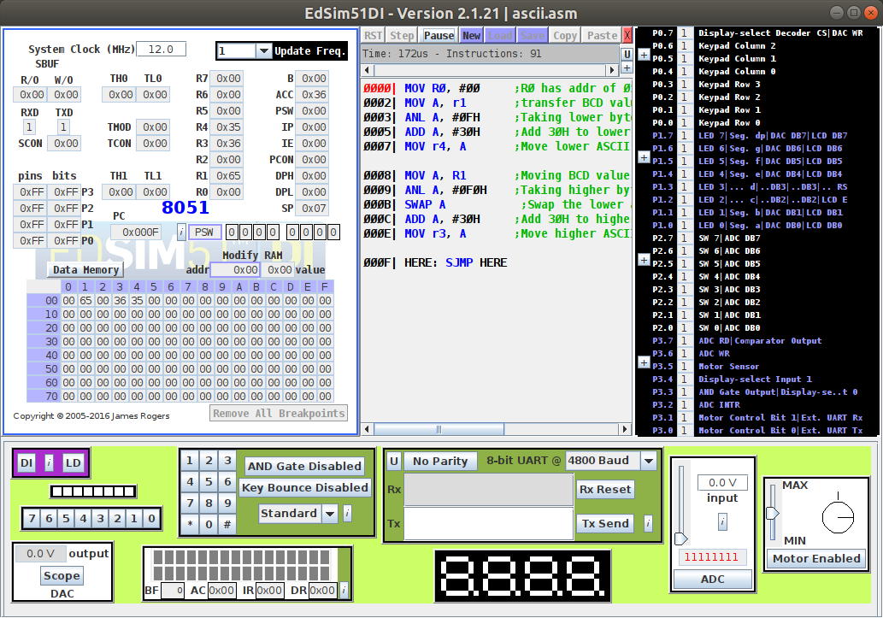

# Result:

An assembly level program was written to calculate the cube of a given 8-bit number using an 8051 micro controller and the output was verified.